Feature Image: Read the top 10 perks!

Title:Top 10 Benefits of Getting Professional Lash Extensions
Focus Keyword: Professional Lash Extensions
Secondary Keywords:
professional Lash Technician
Volume Lashes
Lash Technician
eyelash extensions volume lashes
wispy volume lash extensions

Internal Link:
Volume Lash Extensions: https://lashesbyaree.com/volume-lash-extensions/
Best Eyelash Extensions In houston Tx: https://lashesbyaree.com/

Also write a meta description.

Meta Description:
Learn about the top benefits of Houston professional lash extensions at Lashes by Aree. Save time, boost confidence & get expert volume lashes. Book today!
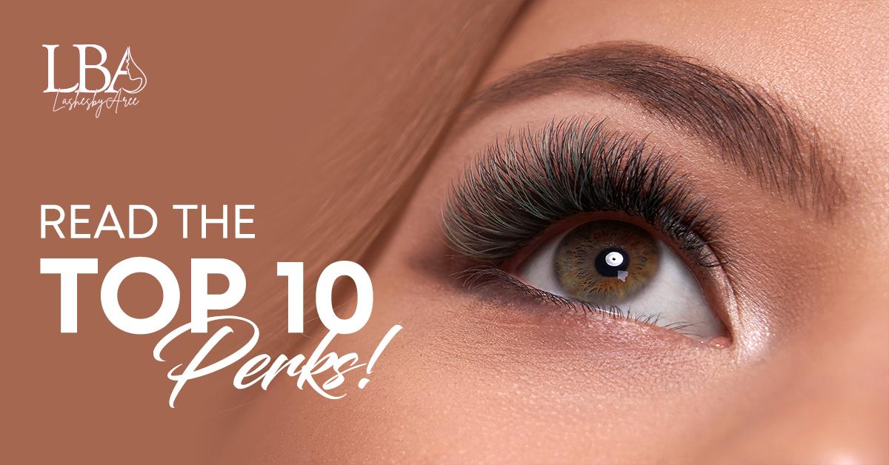

Top 10 Benefits of Getting Professional Lash Extensions H1
At Lashes by Aree, nestled right here in the heart of Houston, we witness daily transformations that go far beyond aesthetics. You might wonder if professional lash extensions are just another beauty trend. Let us assure you that, for countless Houstonians, lash extensions have become a non-negotiable part of their simplified, upgraded lifestyle. With over a decade dedicated solely to mastering the art and science of lash enhancement in our unique climate, we’ve curated the definitive list of the top 10 benefits you experience when choosing true expertise for your lash extensions right here in Houston.

1. Daily Time Savings for Your Busy Houston Life H2
Houston life moves fast. Between navigating heavy traffic, early meetings in the Energy Corridor, or getting the kids to school, your morning minutes are gold. Just simply images in the morning, no more wrestling with clumpy mascara tubes, no smudges before your downtown presentation, no sticky lash glue mishaps.
Professional lash extensions seamlessly integrate into your routine. Wake up, wash your face, and go looking effortlessly polished. Our clients consistently report saving 15-25 minutes every single morning. That’s hours back in your week! We specifically design each set to withstand Houston’s notorious humidity, intense summer heat, sweaty gym sessions at your local Life Time, and even help you maintain your flawless look day in and day out.

2. A Custom Look Designed Just for You H2
Your eye shape, bone structure, and personal style are uniquely yours. Standard solutions simply don't cut it. That’s why at Lashes by Aree, we begin with an in-depth consultation. Our master Lash Technician meticulously maps your natural lash line, assessing growth patterns, curl direction, and density. Are you aiming for a wide-eyed, doll-like effect for an upcoming Bayou City art gala? Or perhaps a soft, natural definition that subtly enhances your everyday look for work at the Med Center?
We expertly blend techniques from classic single lashes for a delicate touch, to hybrid for balanced fullness, or dramatic Volume Lash Extensions using ultra-fine .03mm to .07mm fibers. Unlike temporary strip lashes or ill-fitting clusters, our extensions are individually applied to match and move with your natural growth cycle.

3. Unshakeable Confidence That Lasts Weeks H2
We know Houston weather. Humidity that makes traditional makeup slide off by lunchtime? Been there. Our professional lash extensions are engineered for endurance. We use premium, medical-grade adhesives specifically formulated for longevity and flexibility, rigorously tested in our humid environment. The result? A flawlessly defined lash line that stays impeccably put for 3-4 weeks between fills.

4. Gentle Care for Your Natural Lashes H2
This is where true expertise matters critically. Cheap, quick lash applications often cut corners, gluing multiple heavy extensions to a single, fragile natural lash. This causes breakage, thinning, and long-term damage. At Lashes by Aree, safety and lash health are non-negotiable.
Our professional Lash Technician isolates each and every natural lash before meticulously attaching one lightweight extension. This precision technique ensures the weight is properly distributed, mimicking your natural growth pattern and protecting the integrity of your lashes while creating beautiful density. We complement this with a customized aftercare regimen using Houston-tested products designed to shield your investment from humidity, pollution, and oils.

5. Liberate Yourself from Mascara Mayhem Forever H2
No more raccoon eyes after a hot yoga class at YogaOne, clumpy residue from layering waterproof formulas, the endless cycle of applying, checking, and reapplying throughout the day. Our extensions deliver rich, deep, dark definition and captivating curl 24/7 without the requirement of a mascara wand. Imagine the simplicity! This isn't just about convenience. It's also about a subtle cost saver. Eliminate the constant purchase of high-end mascaras, lash primers, stubborn makeup removers, and lash curlers that pinch. Your lashes look perfect, effortlessly, without the extra pressure of spending money.

6. Gentle Comfort for Sensitive Eyes & Contact Lens Wearers H2
Houston’s pollen counts and air quality can be brutal, especially for those with sensitive eyes or who rely on contact lenses. Many fear lash extensions will exacerbate irritation. We understand deeply. That’s why we exclusively use hypoallergenic, formaldehyde-free, and fume-minimized adhesives proven gentle even on reactive eyes.
Crucially, our technicians are trained to place each extension with a precise 0.5mm - 1mm gap from your eyelid. This ensures zero tugging on the delicate skin and allows your natural lashes to shed freely and comfortably.

7. Instant, Effortless Glamour for Every Houston Occasion H3
Life in Houston is vibrant and demands versatility. Our lash technicians understand very well that you deserve lashes that upgrade your look instantly. Want subtle sophistication? Opt for classic. Craving red-carpet-ready drama without the weight?
You can also opt for Wispy volume lash extensions, which are a signature favorite that layers those ultra-fine fibers for a feathery, textured effect that catches the light beautifully. Need maximum impact? Our eyelash extensions volume lashes technique builds stunning fullness using the lightest possible materials. Our artistry ensures your lashes photograph flawlessly under the bright lights of any Houston event venue.

8. A Tangible Boost in Confidence & Well-Being H3
This benefit transcends vanity. It’s deeply personal. When you look in the mirror and love what you see reflected back. You will see eyes framed beautifully, looking bright and awake. It will greatly impact how you carry yourself. Psychological studies consistently link feeling put-together with reduced stress and increased confidence.
Our customers often tell us, "With my lashes done, I felt completely like myself, just the most radiant version, on my big day." That feeling of alignment, where your outer appearance matches your inner energy, empowers you to walk taller with quiet self-assurance.

9. Committed to Your Long-Term Lash Health Journey H3
We view ourselves not just as technicians, but as partners in your lash health. During your initial consultation and every fill appointment, we conduct a thorough assessment of your natural lash strength, growth cycle phase, and overall eye health. This way, our experts make sure to add the safest weight, length, and curl for your lashes at that time.

10. An Investment in Practical, Everyday Luxury That Pays Dividends H3
Yes, choosing high-quality professional lash extensions involves an initial investment compared to a drugstore mascara or DIY kit. However, let’s break down the true value. Consider the ongoing cost such as high-performance mascara ($25-$35), quality makeup remover ($15-$25), lash primer ($20-$30), potential lash serums for damage control ($50+), and the sheer value of your time spent daily applying and removing makeup. This easily adds up to $50+ per month, not counting replacements or impulse buys.
Now, consider 3-4 weeks of waking up with perfectly defined, beautiful lashes requiring zero daily effort. Our extension sets are designed for longevity with proper care. Plus, our dedicated members enjoy significant savings.

Why Houston Chooses Lashes by Aree? H3
As the Best Eyelash Extensions In Houston TX, we blend artistry with anatomy. Our professional Lash Technician team trains quarterly on safety protocols and trending styles like Hybrid volume or wet-look sets. We source adhesives from FDA-approved labs and never reuse tools.

Final Thoughts: H3
Ready to ditch the lash curler? Visit Lashes by Aree for a pressure-free consultation. We’ll examine your lashes, discuss your lifestyle, and craft a timeline. Bring inspiration pics, because we love a challenge!
With over 2,000 Houston transformations under our belt, we’re confident you’ll see why professional lash extensions are a revelation. Not a chore. Book your appointment today and experience the Lashes by Aree difference.
GMB Description
At Lashes by Aree in Houston, we transform how you experience daily beauty. Our master lash technicians meticulously craft custom professional lash extensions designed exclusively for your unique eye shape and demanding Houston lifestyle. Say bye to mascara smudges forever and reclaim 15+ precious morning minutes daily with lashes engineered to withstand our intense humidity, sweaty gym sessions, and sudden Gulf Coast downpours. We fiercely prioritize your long-term lash health, using medical-grade, fume-minimized adhesives and isolating every single natural lash for safe, stunning volume eyelash extensions that never compromise integrity. Whether you seek volume extension for morning meetings or wispy volume lash extensions for evening nights, we hand-layer each ultra-lightweight extension for looks lasting 3-4 flawless weeks. As the Best Eyelash Extensions in Houston, TX, we uphold uncompromising standards of using FDA-approved materials, medical-grade autoclave sterilization after every client, and cruelty-free Korean silk fibers 30% lighter than standard synthetics. Contact lens wearers and those with sensitive eyes thrive with our hypoallergenic approach, perfected by technicians who personally test every product. Experience the confidence of waking up flawless with us. Book your personalized consultation today and see why Houston trusts our artistry.

